GALLEYWOOD
HORTICULTURAL SOCIETY
Celebrity Evening with
Margaret Thrower
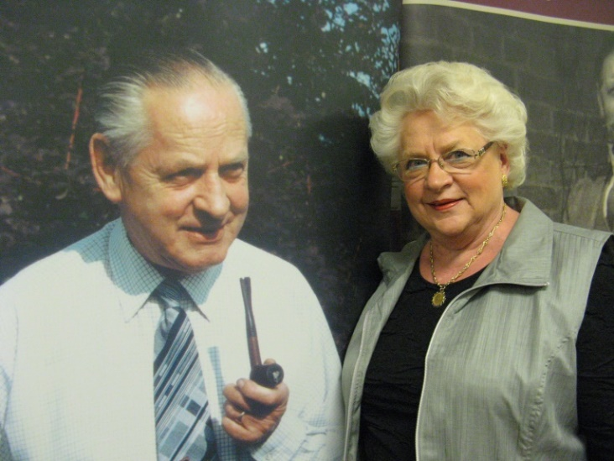
’Three Generations of Gardeners’
Thursday 25th October
8:00pm
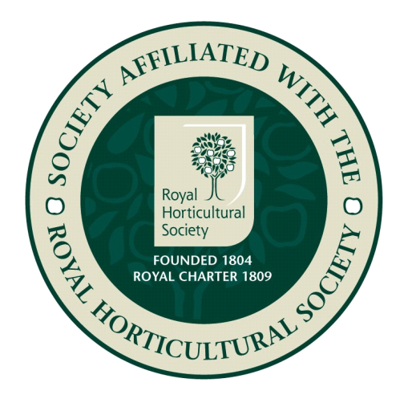
THE KEENE HALL GALLEYWOOD
Ticket prices £6 Member £8 Non members
For tickets please contact 01245 473191

