GALLEYWOOD
HORTICULTURAL SOCIETY
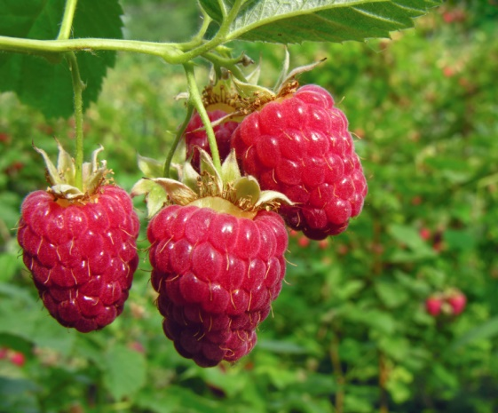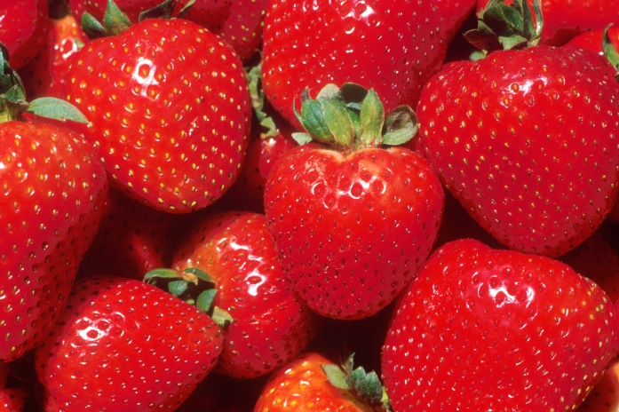
‘Growing Soft Fruit’
By Mike Abel
Thursday 27th September
8:00pm
THE KEENE HALL
GALLEYWOOD
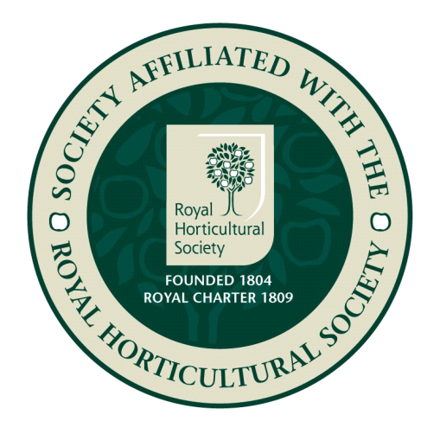

Members free Visitors £3 entrance
www.galleywoodhorticulturalsociety.co.uk

