GALLEYWOOD
HORTICULTURAL SOCIETY
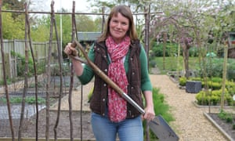
Amateur Gardening’s Lucy Chamberlain Question & Answer session preceded by a short AGM
Thursday 22nd November
8:00pm
THE KEENE HALL
GALLEYWOOD

Members free Visitors £3 entrance
www.galleywoodhorticulturalsociety.co.uk

