GALLEYWOOD
HORTICULTURAL SOCIETY
Christmas wreath and decoration workshop with
Foggy Hau from Marconi Belles WI
Make your own table decoration
Wine and festive nibbles
Thursday 13th December
Earlier start 7:30pm
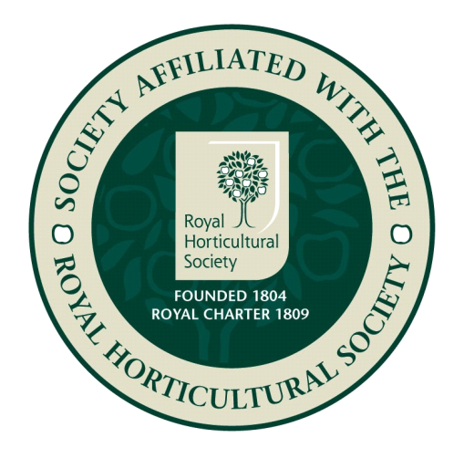
THE KEENE HALL GALLEYWOOD

Members free Visitors £3 entrance
Please see website for further details:
www.galleywoodhorticulturalsociety.co.uk

