GALLEYWOOD
HORTICULTURAL SOCIETY
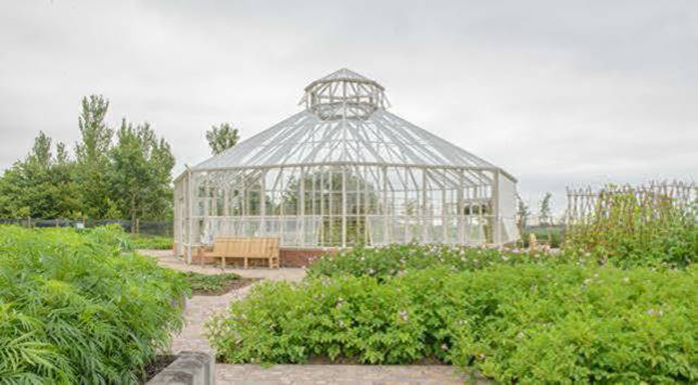
Matthew Oliver
from RHS Hyde Hall
‘Global Growth Vegetable Garden’
Thursday 24th January
8:00pm
THE KEENE HALL
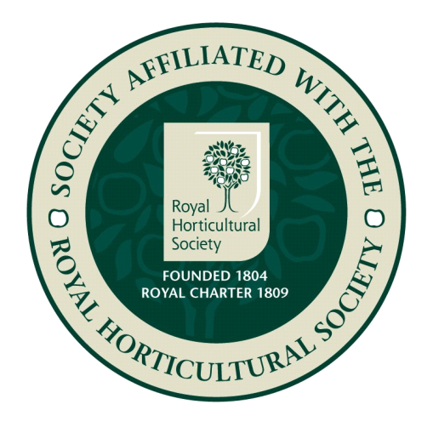
GALLEYWOOD

Members free Visitors £3 entrance
www.galleywoodhorticulturalsociety.co.uk

