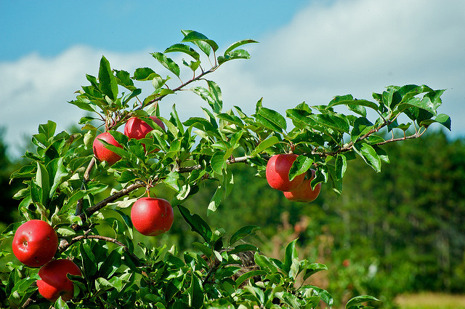
Apple tree pruning workshop at Galleywood Infants School
Saturday 16th February 2019
Starting time 10.30
Please bring along the following:
- Secateurs
- Gloves

