GALLEYWOOD
HORTICULTURAL SOCIETY
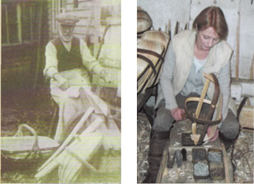
Sarah Page
‘The Sussex Truggery’
As seen on BBC Countryfile
Thursday 28th March
8:00pm
THE KEENE HALL
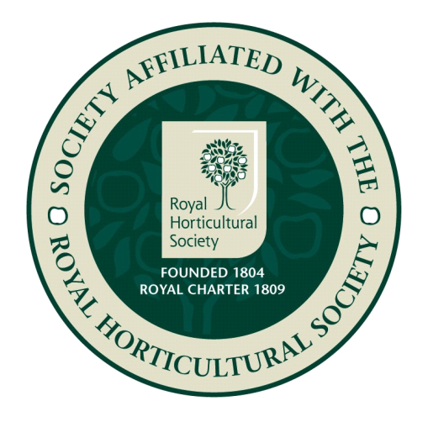
GALLEYWOOD

Members free Visitors £3 entrance
www.galleywoodhorticulturalsociety.co.uk

