GALLEYWOOD
HORTICULTURAL SOCIETY
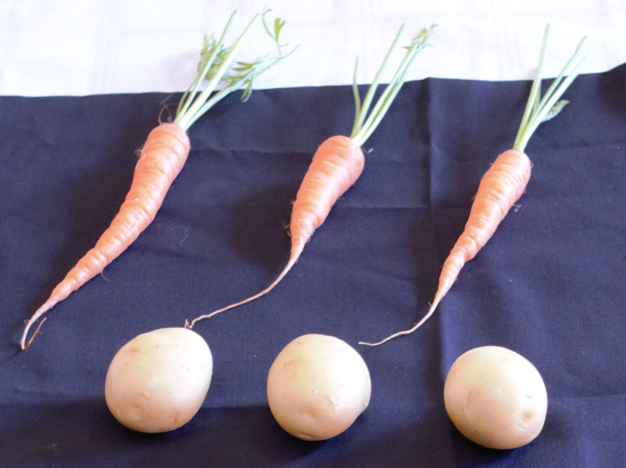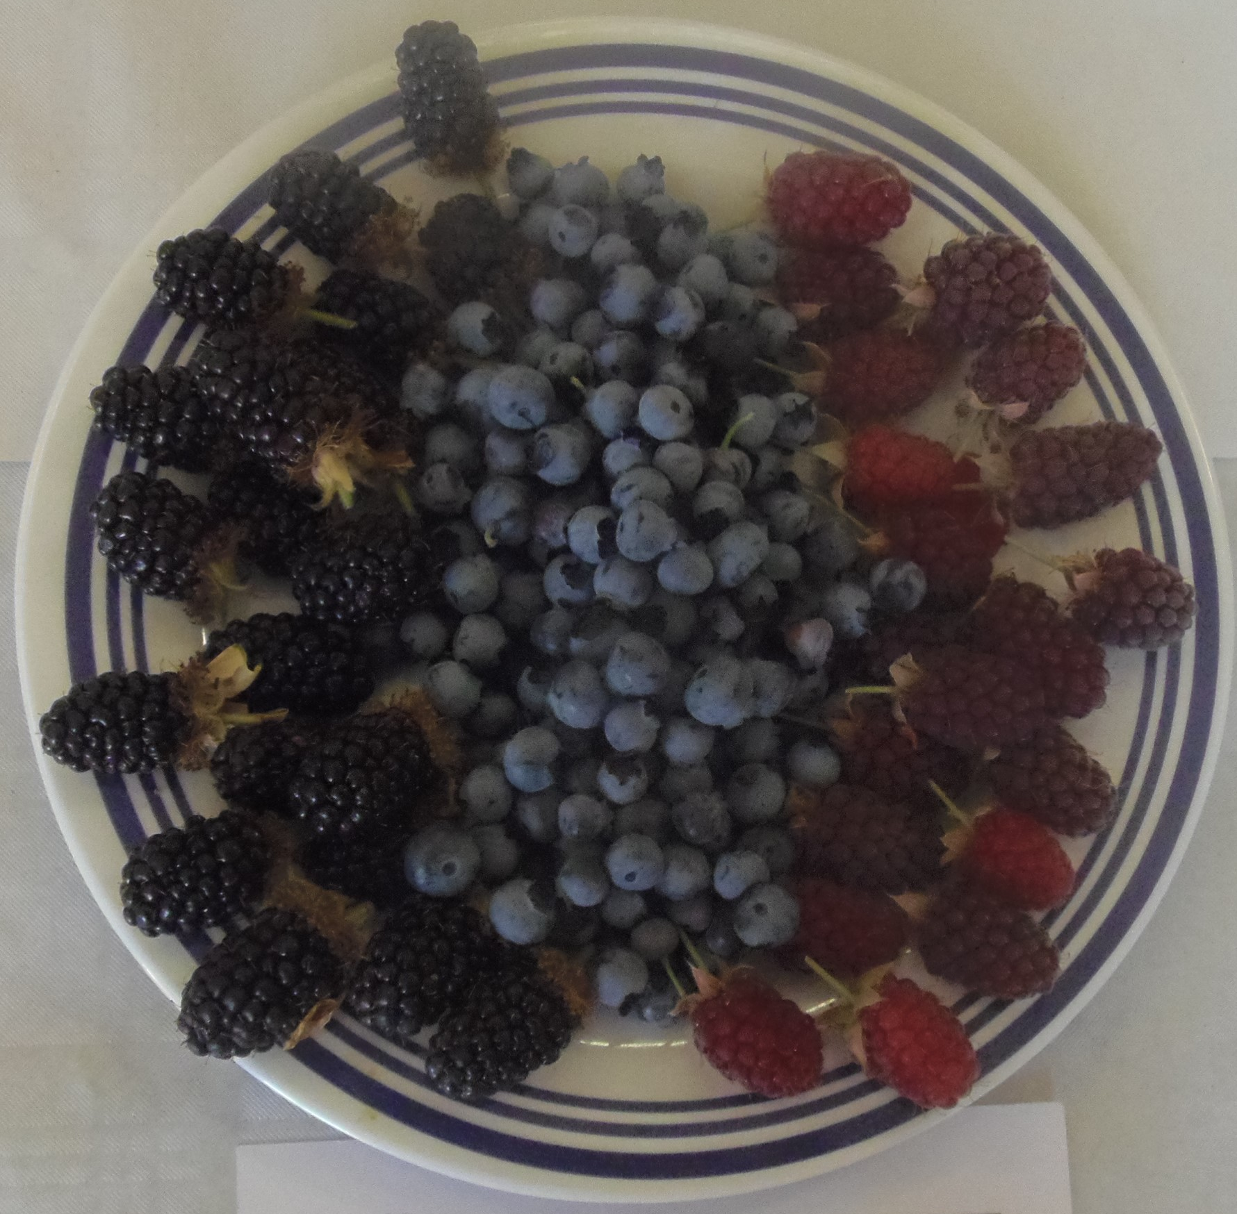
Show Judging
By Tony Rogers
Thursday 23rd May
8:00pm
THE KEENE HALL
GALLEYWOOD

Non-members £3 entrance
For more details contact 01245 473191 or
email galleywoodhorticulturalsociety@gmail.com

