GALLEYWOOD
HORTICULTURAL SOCIETY
2019 Annual Summer Show
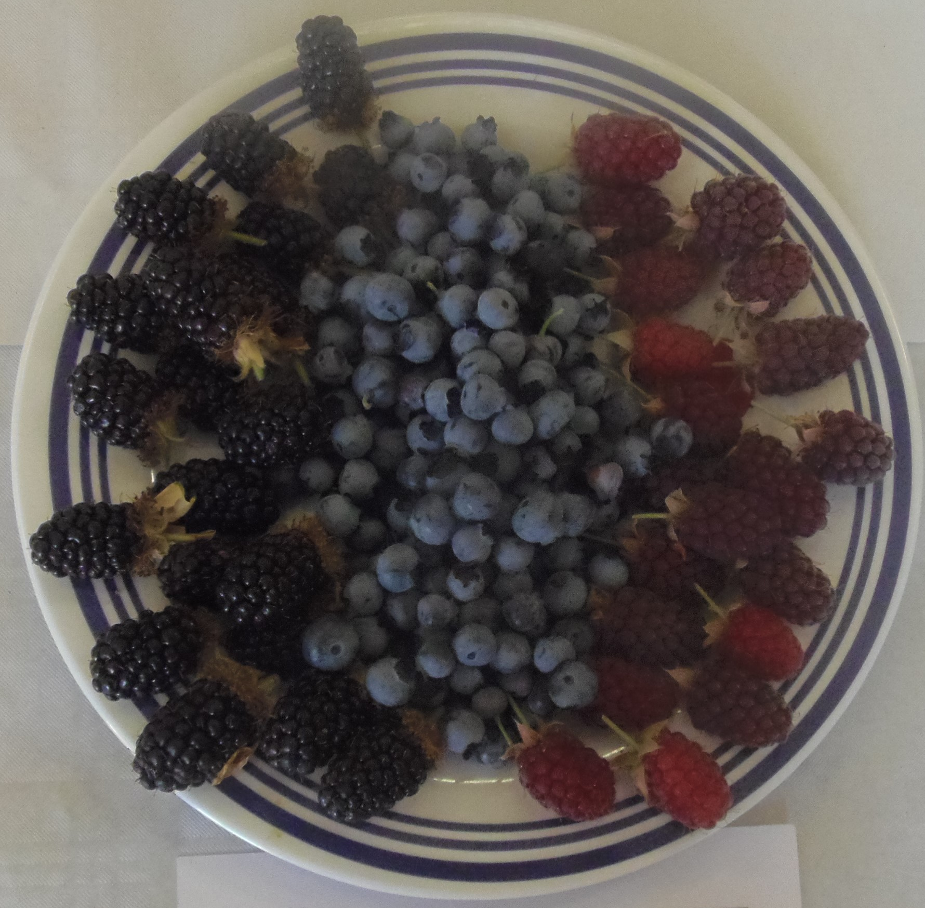
Vegetables, Fruit, Flowers, Cookery, Crafts and Children’s Classes
Entry open to non-members
Saturday 13th July at 2:00pm
THE KEENE HALL GALLEYWOOD
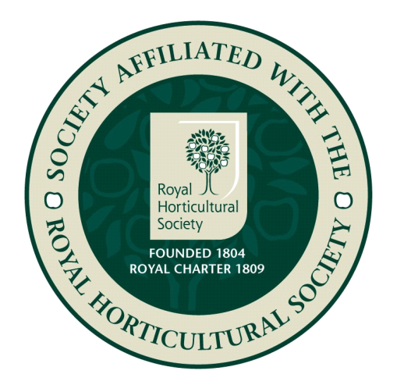
Adults £1 Children Free
Schedules from Keene Hall, Galleywood
Library and Abercorn Garden Centre
For more details Tel 01245 268792
www.galleywoodhorticulturalsociety.co.uk
Supported by Galleywood Parish Council

