GALLEYWOOD
HORTICULTURAL SOCIETY
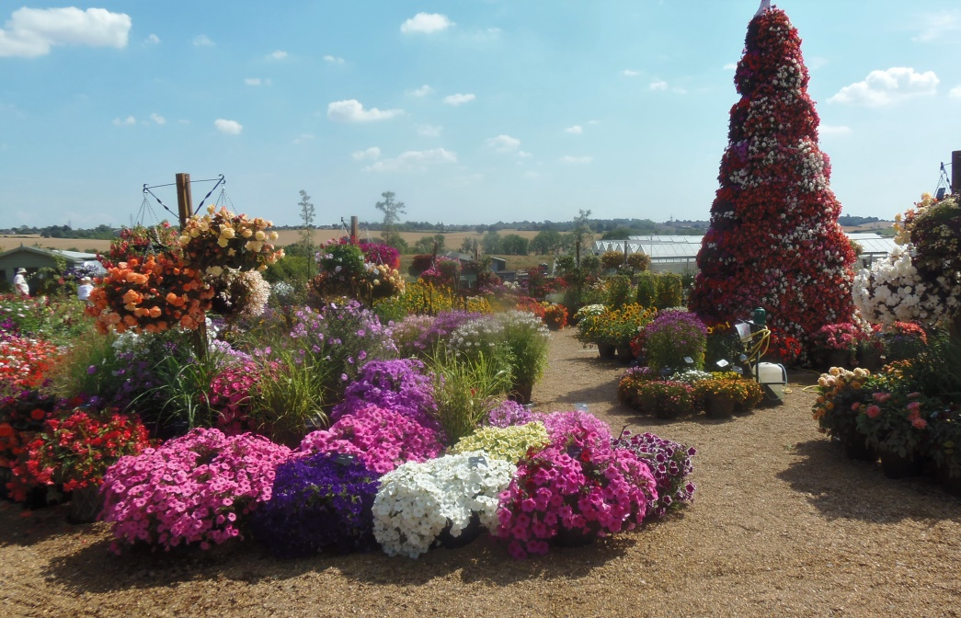
Peter Freeman
‘Floral festival - Hyde Hall’
Thursday 27th June
8:00pm
THE KEENE HALL
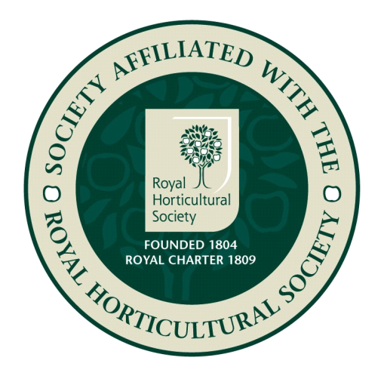
GALLEYWOOD

Members free Visitors £3 entrance
www.galleywoodhorticulturalsociety.co.uk

