GALLEYWOOD
HORTICULTURAL SOCIETY
Celebrity Evening with
Charles Dowding
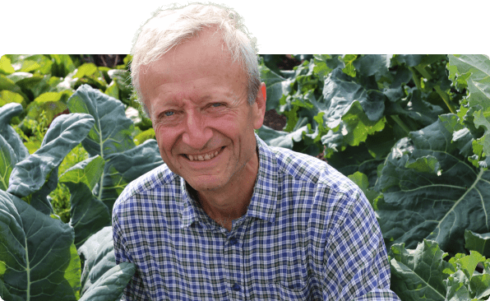
’The No-dig approach to Gardening’
Thursday 24th October
7:30pm
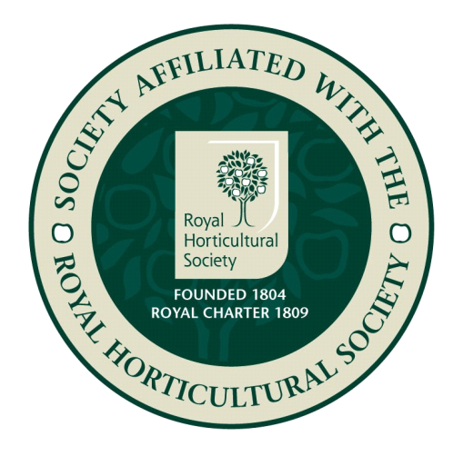
THE KEENE HALL GALLEYWOOD
Ticket prices £8
For tickets please contact 01245 350117

