GALLEYWOOD
HORTICULTURAL SOCIETY
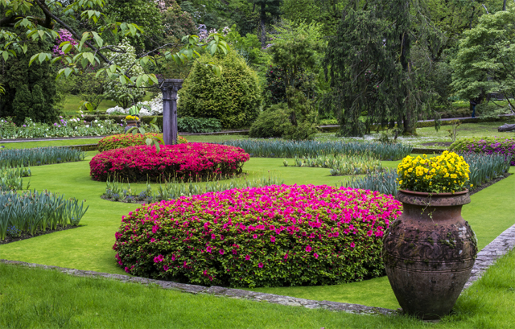
‘Desert Island Gardens - My eight most favourite gardens’
By Margot Bishop
Thursday 26th September
8:00pm
THE KEENE HALL
GALLEYWOOD
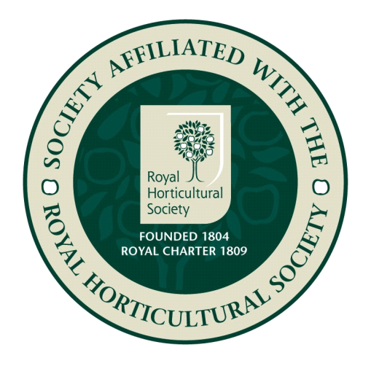

Members free Visitors £3 entrance
www.galleywoodhorticulturalsociety.co.uk

